Backend Engineering Questionnaire and Task

Scenario: Designing a backend platform for Task Management Application

• A software firm is having various departments like Frontend, Mobile, DevOps, Quality Assurance, etc

• Each Department is headed by one or multiple managers

• Firm is taken care by CTO

• Managers are responsible for scaling their team by hiring or removing employees

• Managers are also responsible to assign task to their team members, monitor them and    modify

them

• Managers are strict so they want to see as much information about a task

• CTO should be able to scale the firm by adding more departments as per future requirements

• CTO should be able to assign managers to departments

Questions on scenario:

1. What database would you choose and why?

2. How will you design database schema, or ER diagram, or database modelling?

3. How many APIs can you list down which will be required for the whole scope?

4. How will you deploy this system?

5. How will you monitor your deployment?

6. How many reports from the following will you be able to generate from this system

(a) work efficiency

(b) salary paid each month

(c) team size to number tasks line graph

(d) employee attendance

Task:

Point 2 of Questions on scenario:

General Technical Questions:

1.What is RDBMS and its advantages

2.What is OSI Model

3.What is HTTP and where it is used

Answer:-

1.Mysql will be used for database. It creates a database for storing and manipulating data, defining the relationship of each table. Clients can make requests by typing specific SQL statements on MySQL. The server application will respond with the requested information and it will appear on the clients' side

3. If we want project on public server, then we will need only 1 API. But if we want to put project on local server then API will not be used.

4.If Project wants to deploy on public server then we will using amazon web server,heroku ,000webhost.com,etc.PHP Deployer allows us to set up servers and tasks which we can schedule to run in any order we want on any server we want.

5. Project can monitor codedeploy deployments using the following cloudwatch tools: Amazon cloudwatch Events, cloudwatch alarms, and Amazon cloudwatch logs.reviewing the logs created by the codedeploy agent and deployments can help you troubleshoot the causes of deployment failures. As an alternative to reviewing codedeploy logs on one instance at a time, we can use cloudwatch Logs to monitor all logs in a central location.

6.Report able to generate from this system are:

(a)Work efficiency

(b)Team size to number tasks view page

(c)implanted on comment page for all cto,manager, user as per task.

2.

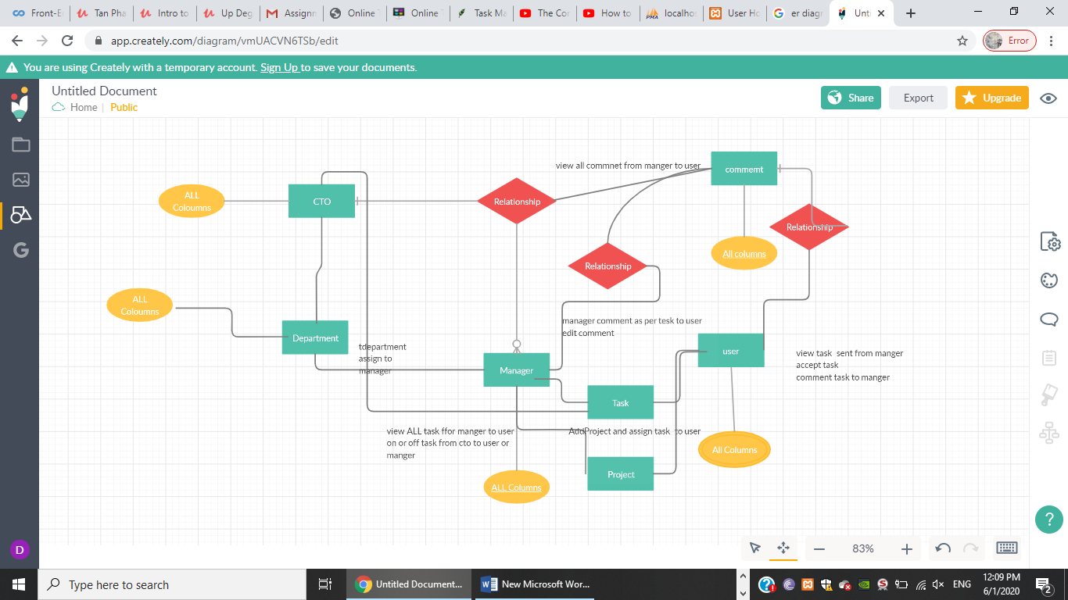

General Technical Questions:

1.What is RDBMS and its advantages

2.What is OSI Model

3.What is HTTP and where it is used

Answer:

1. RDBMS, stand for Relational Database Management System, is a type of database that stores data in a well-organized composite arrangement, comprising of rows and columns, which makes it effortless for the processing of data such as fetching, viewing, updating, deleting and manipulating the contents of the tables, as all the data in each and every table will be holding a relationship with the contents of other tables in the system and all the tables in the database system will be associated to the tables with similar properties.

Advantanges:

#### Maintainability:-It allows database admins to maintain, control, update, data into the database easily. With RDBMS backing up of data becomes easy. Automation tools of RBDMS automate these tasks.

#### Flexibility:Its RDBMS saves a lot of time as updating data at one place is enough.

#### Data Structure:RDBMS stores data in a table format, it is easily understood by the users. Data are organized in a structured manner and matches entries by firing queries.

#### PrivilegesThis feature of RDBMS allows database administrators to control activities over the database. Administrators can give specific access to a user rather than giving all Access. Administrators can also stop user access

2. OSI stands for **Open System Interconnection** is a reference model that describes how information from a software application in one computer moves through a physical medium to the software application in another computer. OSI consists of seven layers, and each layer performs a particular network function. OSI model divides the whole task into seven smaller and manageable tasks. Each layer is assigned a particular task. Each layer is self-contained, so that task assigned to each layer can be performed independently.

Characterstics of OSI are :-application layer,presentation layer,session layer,transport layer,network layer,data link layer,physical layer

3. HTTP means **H**yper**T**ext **T**ransfer **P**rotocol. HTTP is the underlying protocol used by the World Wide Web and this protocol defines how messages are formatted and transmitted, and what actions Web servers and browsers should take in response to various commands.Uses- HTTP is a TCP/IP based communication protocol, that is used to deliver data (HTML files, image files, query results, etc.) on the World Wide Web. when you enter a [URL](https://www.webopedia.com/TERM/U/URL.html) in your browser, this actually sends an HTTP command to the Web server directing it to fetch and transmit the requested Web page.